RTC CUP Rulebook

General Aspects
  - At the "RTC Cup" competitions the participants are presented with a test area. The test area consist of sites of varying complexity from rough terrain to the consequences of disasters (earthquake, tsunami, collapses, mud gatherings and the like).
The purpose of the competition is to inspire children and students to create robots that can work in extreme situations and completely replace a person or act as a helper.
  - In the RTC Cup competition the robot can pass as many test area cells as possible for the given time and perform different tasks.

Test area
  - The test area is a reconfigurable maze consisting of cells. An example of a test area configuration is shown in Figure 1.
  - A detailed description of the test area (types of obstacles and tasks which it contains and their technical characteristics) can be found in Appendix No.1 "RTC Cup Test Area".
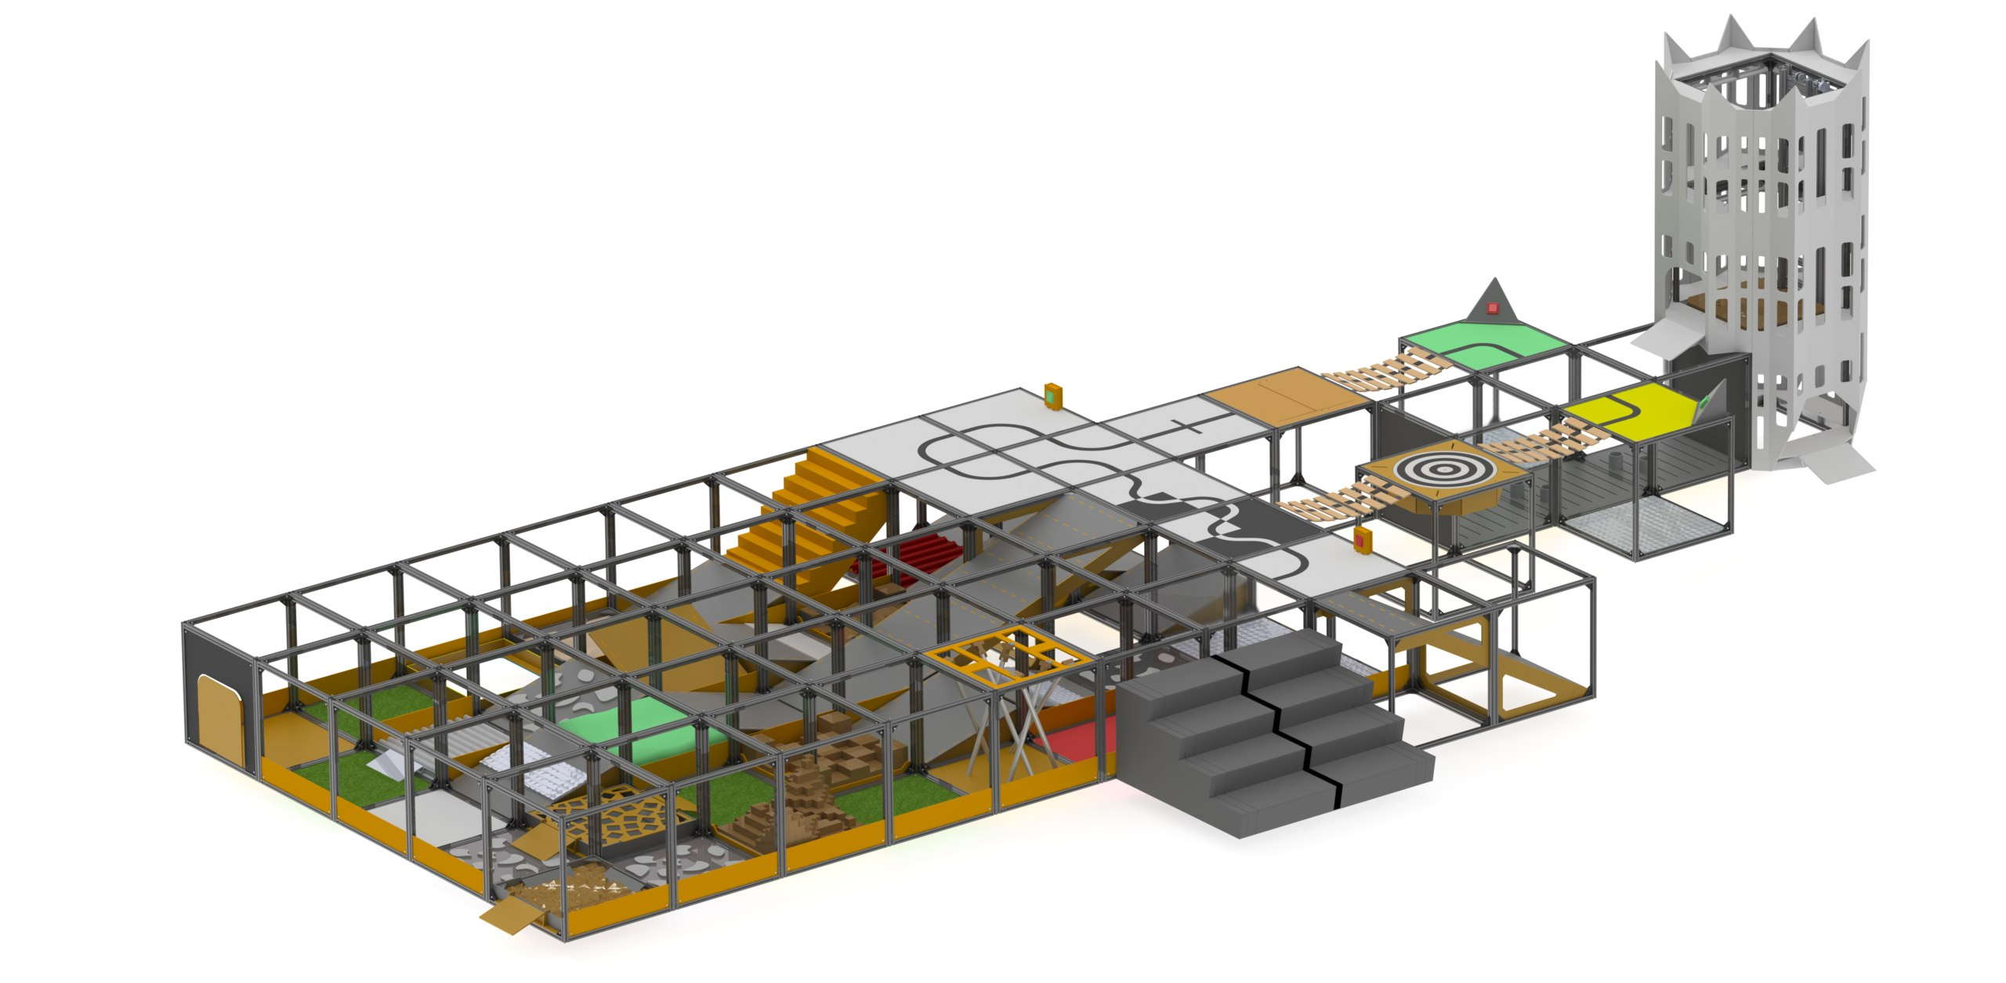
Figure 1 «Example of a test area configuration»

Leagues and Categories
  - Competitions are divided into two leagues: Junior League and Major League.
  - Junior League:
    - Contains two categories: "Extreme" (age limit - from 11 to 16 years inclusive) and "Finder" (age limit - from 11 to 14 years inclusive).
  - Major League:
    - Contains one category: "Extreme Pro" (age limit is 17 or higher).
  - Categories:
  - In the categories "Extreme" and "Extreme Pro", the robot is out of sight of the operator (participant). Operator control the robot in teleoperation mode and can use the data he receive from the robot sensors and camera.
  - In the category "Finder" operator can watch his robot going through test area, by his own eyes.
  - The robot should be controlled remotely.

Requirements for Team
  - There is allowed to be no more than two people in the team (not counting the leader). This rule applies to Robofinist, RoboFest and Final competition.
  - The robot can be operated by only one person.
  - It is allowed to change the operator between attempts.
  - The team can participate with only one robot in only one nomination.

Requirements for Robot
  - There is no restrictions and limitations concerning of which elements robot can be build.
  - The recommended overall dimensions of the robot: no more than 350mm in height, no more than 400mm in length and no more than 400mm in width. After the start of the attempt, the robot can change dimensions.
  - The mass of the robot should not exceed 10 kg.
  - The robot should have an on-board wireless power source.
  - Communication with the robot should be conducted wirelessly. The minimum distance between operator and robot is approximately 10m. Therefore, robots controlled from IR-remote control devices are not allowed for using during the competition.
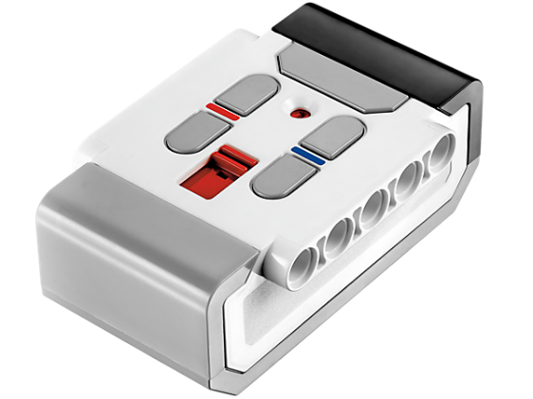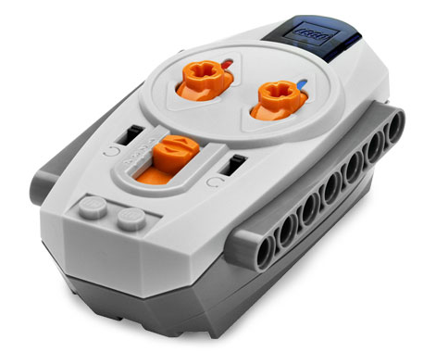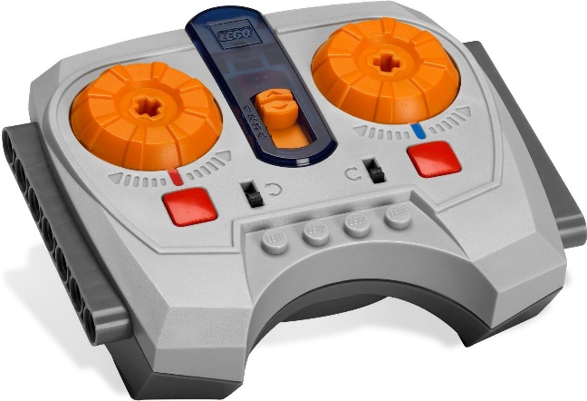
Figure 2 «Examples of IR-remote control devices»

  - For the qualifying round it is allowed to use cables and wires to communicate with the robot (only in the categories "Extreme" and "Extreme Pro"). This rule is made to reduce the possibility of communication problems which happens for reasons that do not depend on the participants.
  - Participants are allowed to use Wi-Fi networks to communicate with the robot during the attempt.

Competitions process
  - The competitions consist of two rounds: the first day - the qualifying round, the second day - the final round.
  - The robot should cross the test area under operator control, passing the tests and performing the tasks. There are beacons of different colors on the test area sites. The robot can collect beacons and place them in the corresponding color zones. Also, the test area contains a block of tasks for checking the characteristics of the robotic arm. There are a number of white fields with black line which can be passed only autonomously.
  - The robot does not have to go through each cell of the test area. The operator can decide how to build his own route.
  - A group training session will be conducted before the start of attempts in each of the two rounds.
  - «Pass/fail» conditions for attempts
    - Mandatory availability and use:
- In categories "Extreme" and "Finder" the robot must use sensors (autonomy, semi-autonomy) or robotic arm to pass the attempt.
- In category "Extreme Pro" the robot must use sensors (autonomy, semi-autonomy) to pass the attempt.
    - Conditions for «pass/fail» in rounds:
- In the qualifying round the robot must meet these conditions during one or more attempts. In this case, all attempts will be counted as the «pass».
- In the final round each attempt will be evaluated separately. The robot must meet these conditions during at least one attempt.
  - First day: qualifying round
    - The test area is divided into 4 sections. Each team chooses 2 any sections.
Thus, each team has 2 main attempts in the qualifying round.
    - One section contains 6 to 9 cells of the test area.
    - Also there is an additional 5th section containing a task (line following) presuming only autonomy operations. The white beacons are placed at intersections (black cross on the white field). Any team can choose to perform one additional attempt on this section.
    - Time for one attempt is 5 minutes. The break between attempts last 5 minutes.
    - During the qualifying round, it is not allowed to remove the functional parts (sensors, camera, robotic arm, levers, wheels, tracks, motors, flipper arms) from the robot. It is allowed to make small changes (add and remove clamps, tape, bands, screws and the like) and change details and modules to the same as was used. Changes must be announced to the judge before the attempt.
    - The schedule of qualifying round attempts would be set up in the morning during the training. Teams would be assembled to draw lots to choose the sections at the beginning of the day.
    - Forming a list of teams for the final round
    - The best 20-25 teams from all nominations qualify for the finals.
  - The second day: the final round
    - Competitions consist of 2 attempts for each categories. The test area is presented as a whole, undivided maze.
    - The attempt lasts 10 minutes.
    - The best of the 2 attempts passes into results table.
    - In the category "Finder" two robots start at the test area, in parallel.
    - In the categories "Extreme" and "Extreme Pro" one robot starts at the test area.

Penalties and time limits
  - Final round
    - Shifting the attempt to another time in schedule will cause 50 points penalty. You can only transfer one attempt and just once.
    - Penalty for interference with the robot during operational mode
      - If the operator uses the right to intervene in the work of the robot, then the team will charged a 50 points penalty. Time for intervention is limited to 5 minutes. You can only intervene once during the attempt.
      - If the robot is stuck in a cell, operator can ask the judge to pick it up and transfer to the point of its arrival in this cell or to the previous cell. This action will be equivalent to intervention.
      - The time will not be stopped during the intervention.
      - The robot cannot stay in one cell for more than 2 minutes. In this case the attempt would be finished.
      - The robot cannot stay outside the test area for more than 5 minutes. In this case the attempt would be finished.
    - Penalties for lost parts
      - The team will be charged 30 points penalty for each lost part (it does not matter if it was a small piece or a whole module).
      - If a part is not connected to the robot and is not moving, it considered lost.
    - Penalty for switching on/off the autonomic mode
      - The autonomic mode should be switched on/off remotely (without touching the robot itself). In this case, the team will not be charged penalty points.
      - To switch from autonomic mode to remote control and back on by using the button placed on the robot, the team should receive 20 points penalty. You can only use two on/off cycles during the attempt.
  - Qualifying round
  - In the qualifying round, there is no penalty for loss of parts, switching on/off the autonomic mode by touching the robot and shifting attempt in schedule.

Judging
  - The operator signs the protocol at the end of the attempt, if he agrees with the results of attempt.
  - All questions arising during the competition are resolved by the judges committee. All participants should accept its final decisions.

